Phase 5: Transform Data & Validate

Navigation:

- Open Employee Test Table from application navigator as shown below.

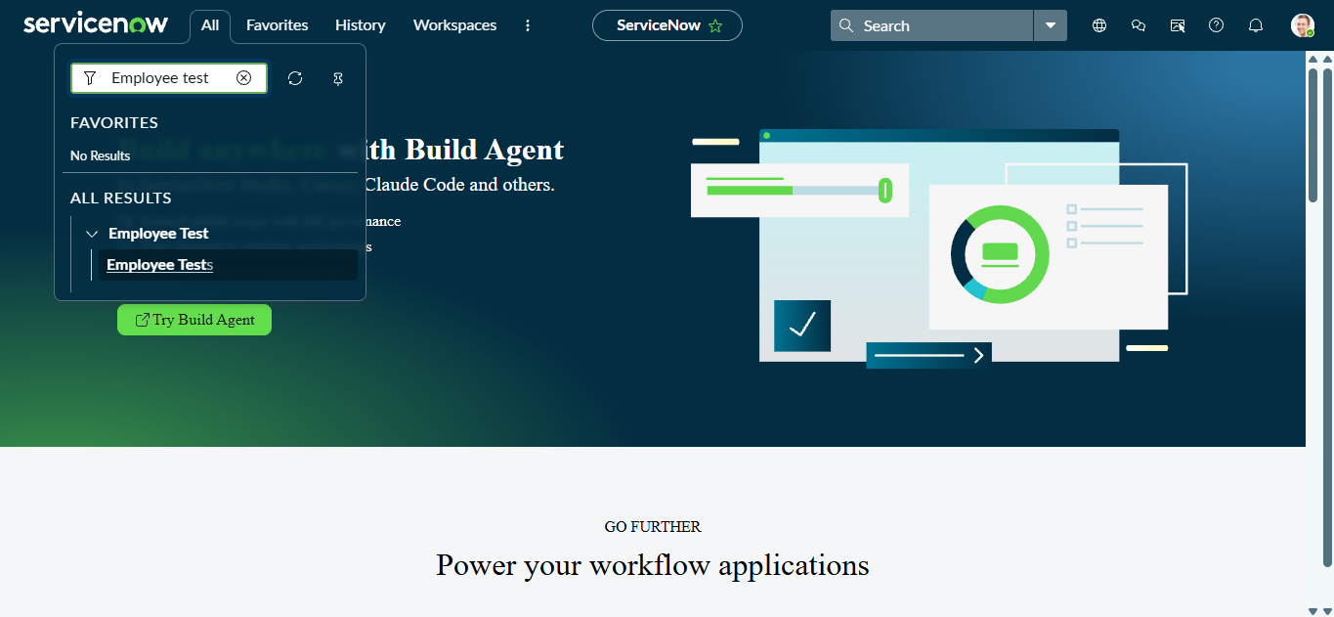

- As our import got succeeded, all the records are created in the Employee Test Table.

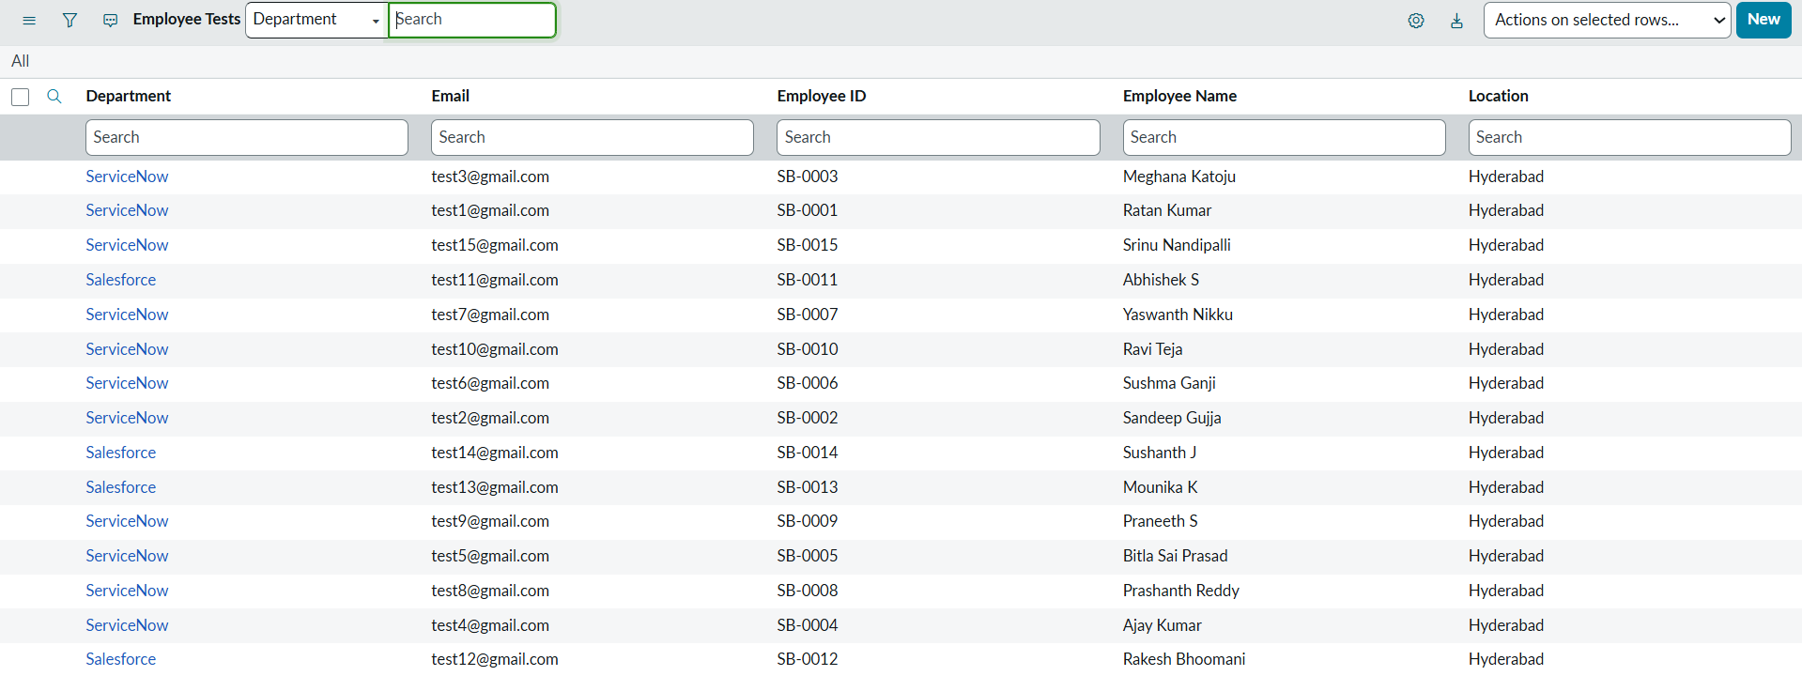

- Make sure you rearrange the fields accordingly by using Personalised List Columns.

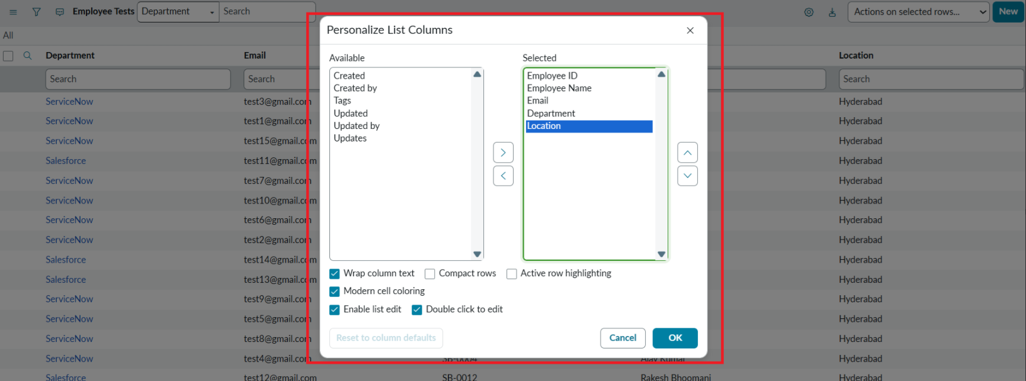

Click on OK

Final Result:

All the records are successfully imported into the ServiceNow system with Import Set, Transform Map.

